  - INSTALLING REACT USING VITE BUILD TOOL
  - npm create vite@latest <project name>

  - INSTALLING TAILWIND CSS
  - npm install tailwindcss @tailwindcss/vite
  - And then Configure vite plugin
import { defineConfig } from 'vite'
import tailwindcss from '@tailwindcss/vite'
export default defineConfig({
plugins: [
tailwindcss(),
],
})

  - And then Import Tailwind CSS in all CSS files
@import "tailwindcss";

  - INSTALLING REACT-ROUTER-DOM
  - npm install react-router-dom

  - INSTALLING NODE-PACKAGE MODULES
  - npm install

  - INSTALLING REDUX & REDUX-TOOLKIT
  - npm install redux react-redux (redux library)
  - OR
  - npm install @reduxjs/toolkit react-redux (redux toolkit, and library)

  - INSTALLING AXIOS
  - npm install axios

  - INSTALLING REACT-ICONS
  - npm install react-icons

  - INSTALLING LUCIDE
  - npm install lucide-react

  - INSTALLING FRAMER MOTION
  - npm install framer-motion

  - INSTALLING REACT SCROLL
  - npm install react-scroll

  - INSTALLING QRCODE Plugin
  - npm install -D vite-plugin-qrcode
Then Import and Configure it in vite.config.js file like
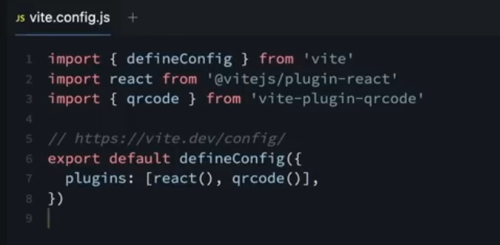
And in package.json we also need to add the option - - host to the dev command this is to expose the app to the network like
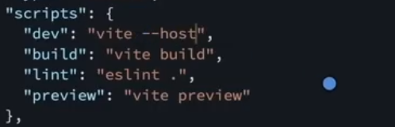
Note:
You Must HotSpot Your PC Using your phone for it to work
  - INSTALLING date-fns
  - npm install date-fns

  - INSTALLING snowfall
  - npm install react-snowfall

LOADING ANIMATIONS
  - INSTALLING react-spinkit
  - npm install spinkit
After installing it you need to import it to the starting of your app eg main.jsx so as the spinners can be accessible all over your app

  - INSTALLING react-typed
  - npm install react-typed

Then you import it and use it with props Example;
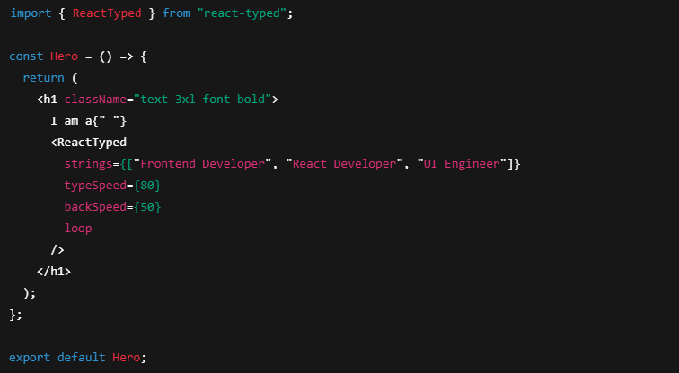
  - INSTALLING react-query
  - npm install react-query

